#WAP to find area of circle

rad=float(input("Input radius"))

area=3.14\*rad\*rad

print(area)

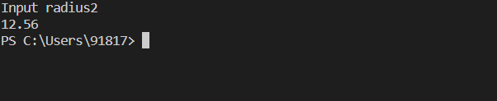

#WAP to input three sub marks and find average and percentage

marks1=int(input("Enter 1st subject marks"))

marks2=int(input("Enter 1st subject marks"))

marks3=int(input("Enter 1st subject marks"))

avg=(marks1+marks2+marks3)/3

percent=((marks1+marks2+marks3)/300)\*100

print(avg)

print(percent)

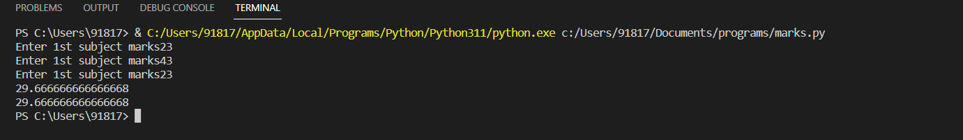

#WAP to find BMI

weight=float(input("Enter weight"))

height=float(input("Enter height"))

bmi=weight/(height\*\*2)

print(bmi)

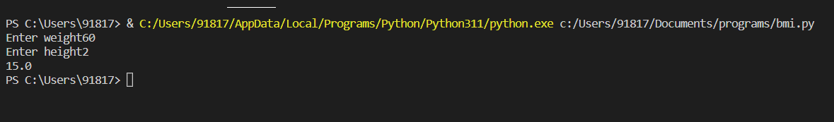

#WAP to calculate area of triangle

base=float(input("Enter base"))

height=float(input("Enter height"))

area=0.5\*base\*height

print(area)

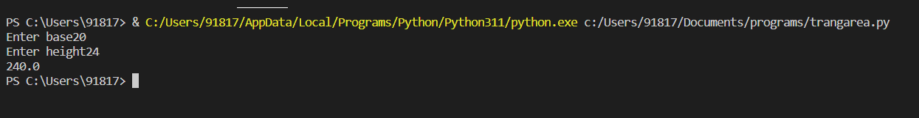

'''WAP to generate following output

5

 10

 9

 and 5@10@9'''

a=5

print(a)

print(2\*a)

print(2\*a-1)

print(a,2\*a,2\*a-1,sep="@")

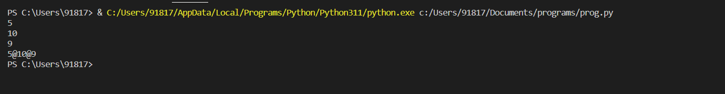

#WAP to calculate simple interest

principle=int(input("Enter principle"))

rate=float(input("Enter rate"))

time=int(input("Enter time"))

si=(principle\*rate\*time)/100

print(si)

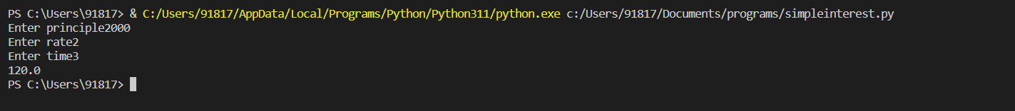

#WAP to convert celcius into farenheit

temp=float(input("Enter temperature"))

conv=(temp\*9)/5+32

print(conv)

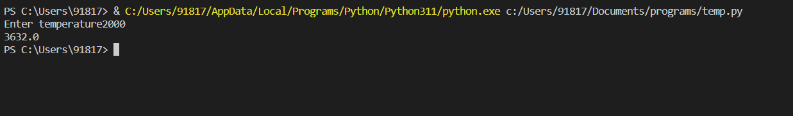

#WAP to find compound interest

pri=int(input("Enter principle"))

rate=float(input("Enter rate"))

n=int(input("Enter no of times interest applied"))

time=int(input("Enter time"))

amount=pri\*((1+(rate/n))\*\*(n\*time))

ci=amount-pri

print(ci)

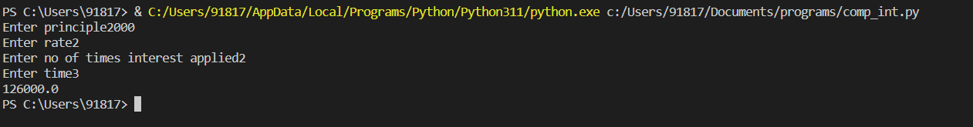

#write a program to calculate emi

p=int(input("Enter principle"))

rate=float(input("Enter rate"))

n=int(input("Enter tenure of months"))

emi=p\*rate\*((1+rate)\*\*n)/((1+rate)\*\*n-1)

print(emi)

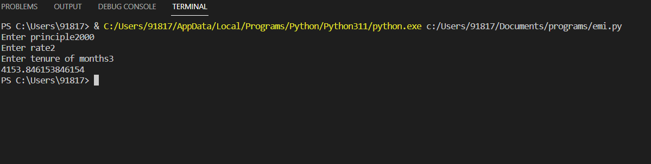

#WAP to calculate emi using power function

p=int(input("Enter principle"))

rate=float(input("Enter rate"))

n=int(input("Enter tenure of months"))

#from math import \*

emi=p\*rate\*(pow((1+rate),n))/(pow((1+rate),n)-1)

print(emi)

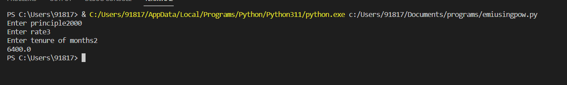

#WAP to convert celcius into kelvin

temp=int(input("Enter temp in celcius"))

conv=273.15+temp

print(conv)



#WAP to find area of triangle using heron's formula

s1=float(input("Enter 1st side :"))

s2=float(input("Enter 2nd side :"))

s3=float(input("Enter 3rd side :"))

s=(s1+s2+s3)/2

from math import \*

area=sqrt(s\*(s-s1)\*(s-s2)\*(s-s3))

print(area)

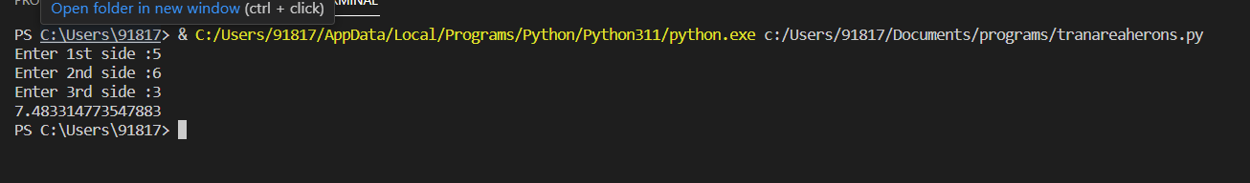

#WAP to print minute in mainute and seconds

time=int(input("Enter time in seconds :"))

a=time//60

b=time%60

print("it is",a,"min and",b,"seconds")

